**InfraStruxure Central 6.2.0**

**Introduction**

InfraStruxure Central 6.2.0 is the monitoring software that collects, organizes, and distributes critical alerts and surveillance video for the Kansas State University Data Center. This data is used to monitor support equipment such as; power distribution units, uninterrupted power supplies, and cooling devices, both from a diagnostic standpoint through complex real time reports, as well as physically monitor through a live video feed.

With timely monitoring and proper use, the InfraStruxure software can help predict and prevent failures of mission essential equipment. An operator must know how to fully utilize this software to help guarantee maximum resource efficiency.

**Basic Functions**

**Login**

InfraStruxure has a very simple and easily navigable layout. Upon starting up the InfraStruxure program, this is what you will see.

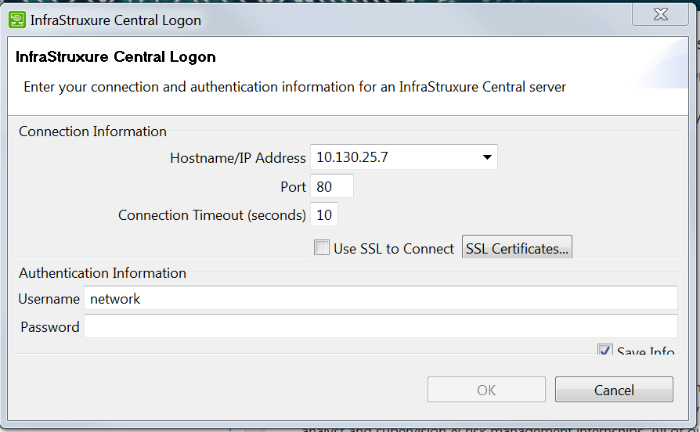

Leave all settings as they appear in the window above. The Username is ******** and the Password is ********. After logging in, the program will open into its welcome screen as shown below.

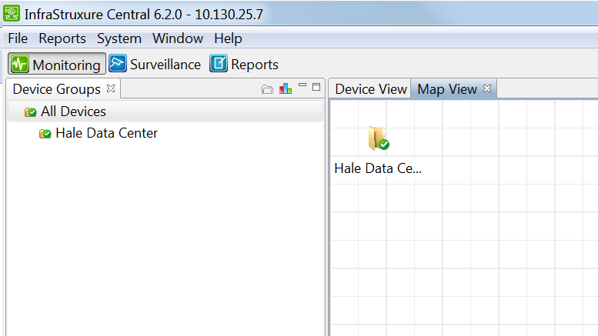

**Monitoring**

Upon entering the home screen, click on the “Hale Data Center” folder to open the list of monitored devices. The below screen will appear to show the physical layout of the devices.

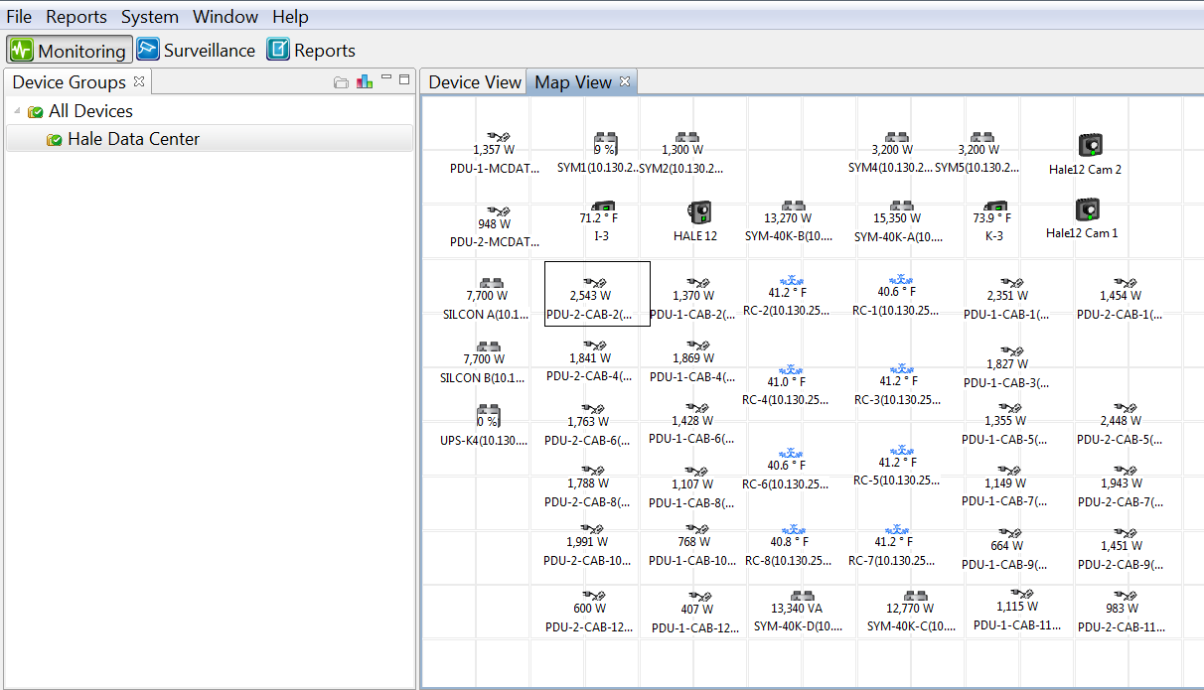

By clicking the “Device View” tab, the layout will change to a list format that can be sorted by many different attribute fields such as; device type, hostname or status, as shown below.

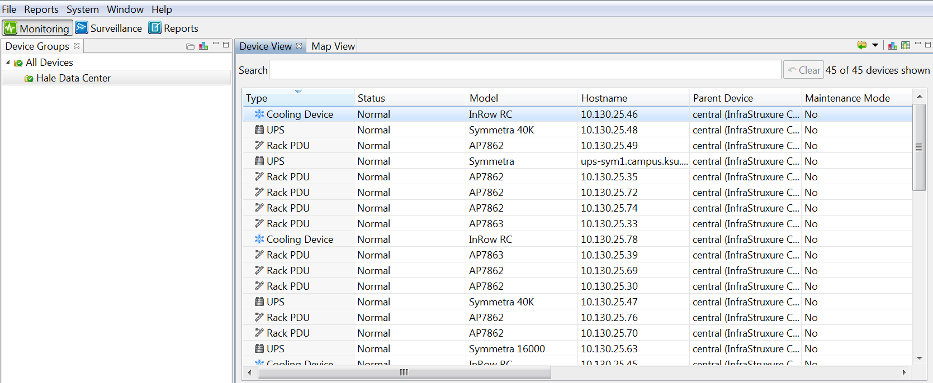

From the Home Screen you will also notice on the bottom of the screen there is a section for active alarms. This displays all current equipment failures/warnings, and lists its description, hostname, alarm, and recommended action. If this menu isn’t showing simply click the “Alarms” button on the bottom right hand corner of the screen.

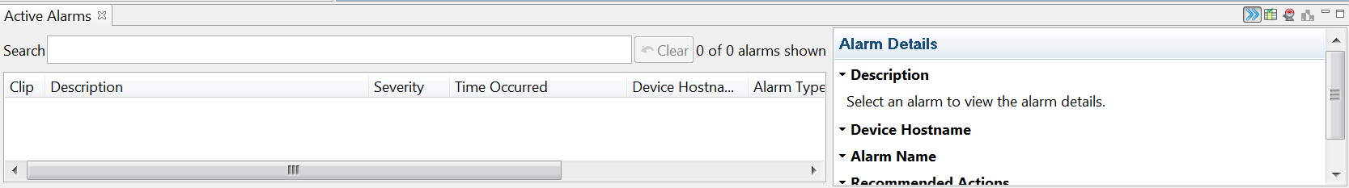

**Surveillance**

As stated earlier, InfraStruxure can feed live video from security cameras in the data center. The data center has two separate cameras monitoring its equipment. You can access these cameras by clicking the “Surveillance” button in the top left hand corner as shown below.

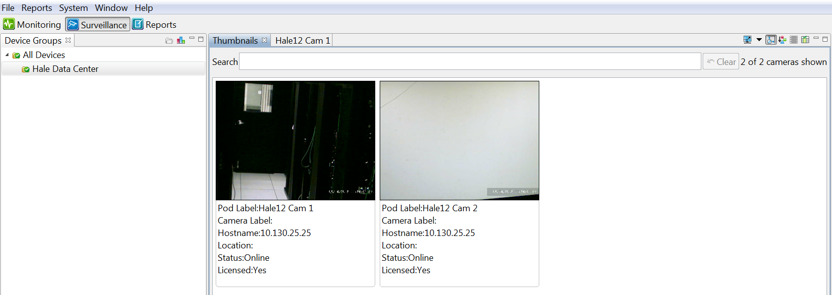

As well as showing a live feed, InfraStruxure stores video clips for a predetermined amount of time. To retrieve these stored clips simply right the video feed and select “Retrieve Clips” from the drop down menu. The screen below will then appear.

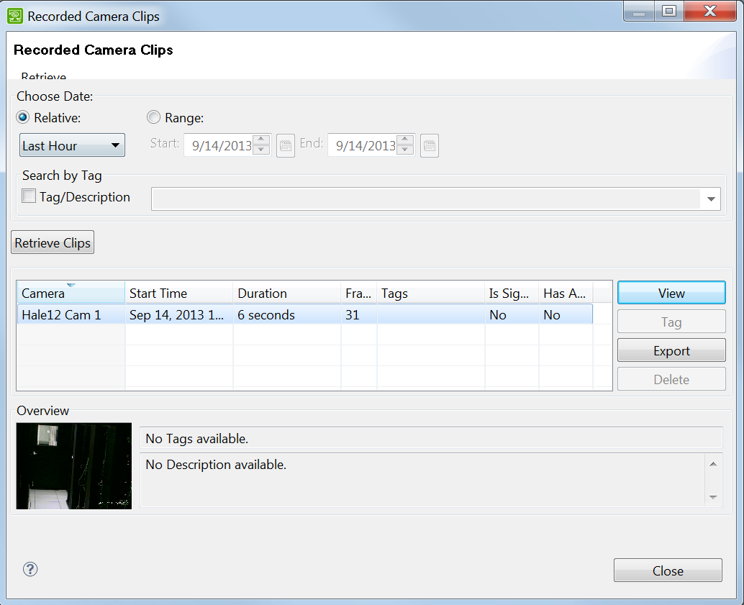

From here you can select a time frame or date to retrieve video clips from. Once a time frame is selected, click the “Retrieve Clips” button to see all clips from the selected time. After the clips have populated, select the clip you wish to view and click the “View” button on the right hand side of the screen. Upon selecting “View” the window below will appear. You can scroll through the clip as necessary, and once done you can click “Close” to close the window.

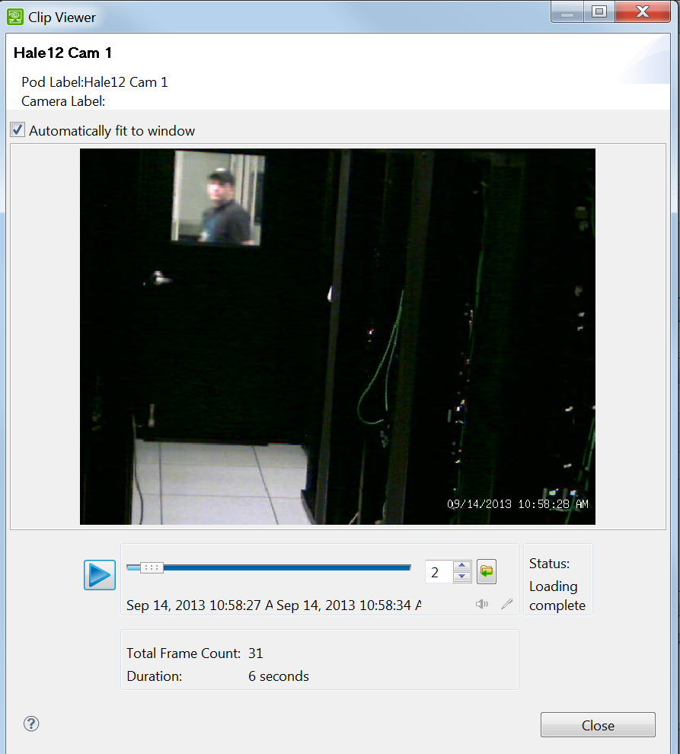

**Reports**

The last feature of InfraStruxure is the “Reports” tab. From here you can generate many different kinds of reports to help in diagnosing, or treating equipment failures. There are two kinds of reports we are concerned with, “Sensor History” and “Snapshot”.

Sensor History

Upon opening the “Reports” tab you will see the different options for generating reports. The first category of reports is the “Sensor History Reports”. First select which sensor report you would like to view. Then click the “Generate Report” button at the bottom of the report selection panel. 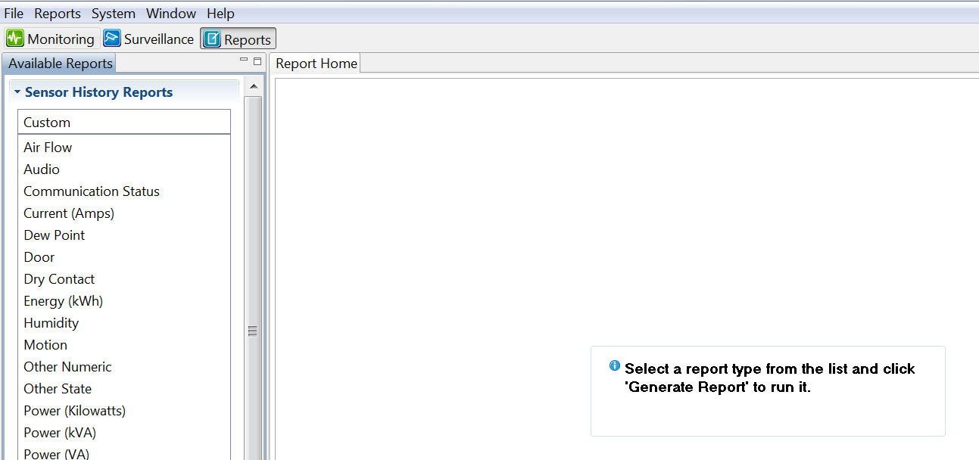

Upon clicking “Generate Report” then window below will appear. From here the sensor type you selected will be chosen for you already. You can also select a time range and format for the report from this screen.

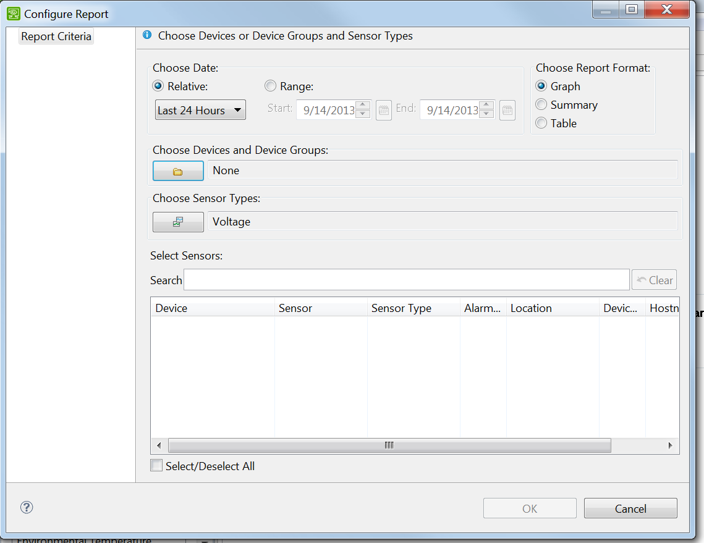

Before you’re able to generate the report you must first specify what devices you would like to view the statistics for. To do this, simply click the folder icon under the “Device Groups” section of the menu to bring up the menu below. From here, you may select the devices you wish to see information on. After selecting your devices simply select “Generate Report”.

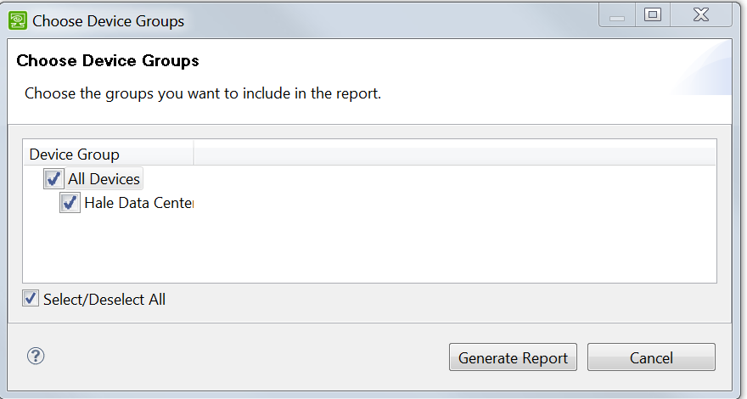

Snapshot Reports

The second kind of report that can be generated from InfraStruxure is the Snapshot report. These are quick system reports that are used to get an overview of the health of the network support devices very quickly.

Simply select the snapshot report you wish to run from the report home section and you will be prompted to select the devices to view as before, but you will not be given the customization options as you would with a “Sensor History” report.



The above list of features is not a comprehensive list of the functions for InfraStruxure, but they are the main features used by Network Operations Center staff. For a complete overview of functions please refer to the software guide.

**Reporting**

Timely and accurate reporting of server support hardware warnings and/or failures will help ensure maximum up time of K-State network resources. Each category of equipment/failure has their own reporting requirements. They are listed below.

**PDU – Power Distribution Units**

You will monitor Power Distribution Units (PDU) for audible and silent alarms. You should report all alarms and alerts with maximum information; for example, power an overvoltage alarm you would obtain the readings for x-y, y-z, z-x and kVA. The recorded information will be sent to HARDWARE at [*hardware@listserv.ksu.edu*](mailto:hardware@ksu.edu)and also to OPSREPORT at [*opsreport@listserv.ksu.edu*](mailto:opsreport@ksu.edu). These alarms will also be recorded in the Problem Log and in the Total System Log. There is a form available to record the readings in the NOC Logbook as well as in the Auxiliary NOC Logbook. All status updates should be made in a timely manner. All emails will be very detailed in nature to include the type of alarm and the appropriate readings for x-y, y-z, z-x and kVA. Also, you should include all actions taken in the shift report.

**Cooling Units**

Monitor the Cooling Units for audible and silent alarms, and that cool air is blowing out of the units. If the cooling units have a “Check Log” alarm follow the procedure below to clear the alarm and gather further information1. Send all information in an e-mail to the Data Center Manager, HARDWARE at [*hardware@listserv.ksu.edu*](mailto:hardware@ksu.edu), Danny Fronce at [dif@ksu.edu](mailto:dif@ksu.edu), and carbon copy OPERATIONS-L at [*operations-l@listserv.ksu.edu*](mailto:operations-l@listserv.ksu.edu) unless a warning or critical alarm is showing then follow the critical contact procedure2.

1

1. Push the ESC key and use the arrow keys and tab to ALARMS.
2. Push the Enter key ( **↵** ) use the arrow keys and tab to Alarm/Event Logs
3. Push the Enter key ( **↵** ) to view the log entry. Use the arrow keys to scroll through the message. You should write down the message for documentation purposes.
4. Push the ESC key and use the arrow keys and tab to Clear Logs.
5. Push the Enter key ( **↵** ). You may not be able to clear the log and you will get a message to enter the administrator pass code. We do not have the pass code. The Check Log light will stay on if you could not clear the log.
6. Push the ESC key until you return to the main screen.
7. Be sure you check each unit on both racks to ensure they are blowing cool/cold air.

**NOTE:** If a unit is **NOT** blowing cool/cold air this is a **CRITICAL** problem and the Data Center Manager should be contacted immediately, as well as Danny Fronce at [dif@ksu.edu](mailto:dif@ksu.edu).

2When there is a **WARNING** or a **CRITICAL** alarm that requires an administrator password and is related to the water temperature, first, notify the HVAC on-call staff directly at 785-313-5859. If no answer, leave a detailed message on the answering machine. Then, call the KSUPD and ask them to notify the HVAC on-call staff. Also contact the Data Center Manager by phone and then Danny Fronce by phone immediately at 785-532-4563. Send an email to the Data Center Manager, HARDWARE at [*hardware@listserv.ksu.edu*](mailto:hardware@ksu.edu), Danny Fronce at [*djf@ksu.edu*](mailto:djf@ksu.edu), and carbon copy OPERATIONS-L at [*operations-l@listserv.ksu.edu*](mailto:operations-l@listserv.ksu.edu). If unable to reach Danny Fronce, call Eric Sivertson at 532-0025. Include this information in the shift report.

**InfraStruxure**

If there is a warning or critical alarm on the APC InfraStruxure Central, check the web camera views to see if staff is working in the area. If you see APC staff is working in the area, make note of the time the alarm was noticed and that staff were working in the area to be included in the shift report. Regardless, if staff are working in the area or not, you need to send an email to the Data Center manager, HARDWARE at [hardware@lsitserv.ksu.edu](mailto:hardware@lsitserv.ksu.edu), Danny Fronce at [*djf@ksu.edu*](mailto:djf@ksu.edu), and carbon copy OPERATIONS-L at [*OPERATIONS-L@listserv.ksu.edu*](mailto:OPERATIONS-L@listserv.ksu.edu)*.* The email should include the type of alarm (warning or critical), the device the alarm is on, and the time the alarm was recognized. If a critical alarm has occurred, after the email has been sent, call the Data Center Manager as well as, Danny Fronce at 532-4563 and leave a message if they are not available. If you cannot reach Danny please call Eric Sivertson at 532-0025 and if no answer, leave a message. If you notice while you are on the roaming check that the battery rack load percentages have a “Check Log” alarm, follow the procedures in the NOC Guide under the APC Rack Information tab, to clear the light. You need to send email to the Data Center Manager, HARDWARE at [*hardware@listserv.ksu.edu*](mailto:hardware@listserv.ksu.edu) and Danny Fronce at [*djf@ksu.edu*](mailto:djf@ksu.edu)and carbon copy OPERATIONS-L at [*OPERATIONS-L@listserv.ksu.edu*](mailto:OPERATIONS-L@listserv.ksu.edu).